Dear NWMS patient,

We are very excited to let you know about a program that Northwest Medical Specialties is recommending for all of our patients with multiple myeloma. A Seattle-based company All4Cure has created a free online platform that summarizes your medical history and allows you and your doctor to communicate with other doctors, researchers, and patients in deciding which treatment might work best for you. Sharing your medical history on All4Cure will allow you and your doctor to learn from other All4Cure patients and will also allow others to learn from you.

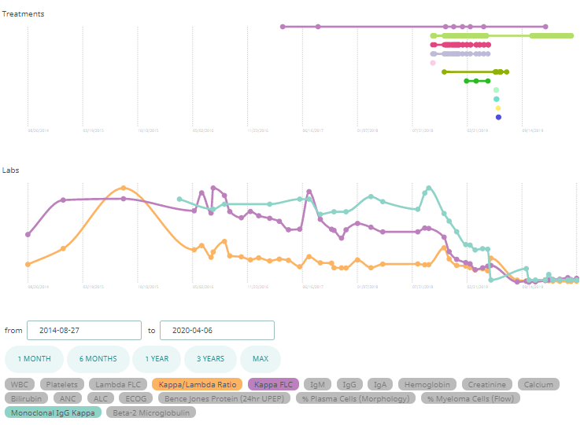
As part of this program, All4Cure asks for your permission to access your medical records and creates your personalized dashboard (example on the right) that you and your doctor can use to post comments or questions that could be answered by other participants on All4Cure. Your personalized dashboard depicts a comprehensive history of your cancer, including all labs and treatment that you have received from diagnosis to present.

Your participation is anonymous; your dashboard will not contain your name, address, phone number, social security number, or any other personal information.

Please note that participation in All4Cure is voluntary, and if you decide not to participate in All4Cure you will continue to be cared for by your doctor as usual. Please also review the Terms of Service and Privacy Policy which can be found at the bottom of the homepage. If you would like to participate, there are a few quick and easy steps in this process:

- Access the website by searching for www.all4cure.com
- Click APPLY NOW at the top right-hand corner of the page.
- Input your email address and a password.

Once you complete the registration process, an All4Cure team member will be in contact with you to request your medical records, answer any questions you may have, and walk you through your dashboard.

If you have any questions or need assistance, please email support@all4cure.com or call Dr. Tony Blau (a fellow myeloma patient) at (206) 412-1787.

Best regards,
Northwest Medical Specialties

